Senior Project Manager
POSITION PROFILE

ontents
The Company 3
The Opportunity 4
Preferred Candidate Profile 5
Remuneration & The Recruitment Process 6

ALS is building the UK’s leading dental manufacturing business. It was created in 2019 by Ansor LLP partners Peter Strafford and Peter Marson. They identified that the dental laboratory industry was on the cusp of transformation with the potential to improve products and solutions for dentists and patients whilst delivering significant growth and value by building a large dental laboratory group.

Dental manufacturing is undergoing a rapid transformation from a fragmented industry of small laboratories staffed by experienced dental technicians making crowns, bridges, and other dental products by hand to a world of digital workflows and large-scale automated production involving intra-oral scanning, 3D printing and robotics.

ALS’s goal is to build the UK’s leading, most innovative and technologically advanced dental manufacturing group, positively disrupting the industry and advancing its capability by integrating progressive businesses, advanced technologies and skilled people.

ALS 2022 budget for existing businesses is £3.6m EBITDA and it is targeting £27m+ EBITDA by 2025 in its base case plan. The company is currently expanding to have nationwide UK coverage and plans to enter the international laboratory market. ALS is on the acquisition trail, having grown from start-up at the end of 2019, to currently 24 sites, through a mixture of acquisition and organic growth in the crown and bridge and orthodontic segments. ALS has a strong pipeline of future acquisitions and new products that will continue to drive the rapid expansion and development of the group. It is a very exciting time to be joining the business.

The business is led by CEO Tom Lavery, formerly Managing Director and Chairman of Johnson & Johnson Medical UK & Ireland and Kenny Burns, CFO.

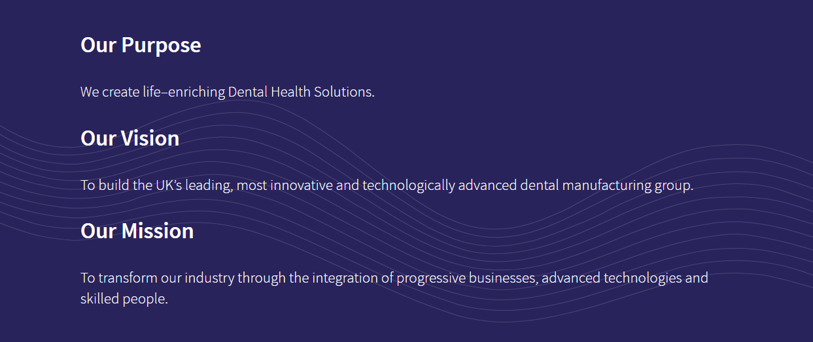
More information on ALS can be found on their website: https://als-dental.com/ and across their different digital channels: LinkedIn, Instagram, YouTube, Facebook, Twitter.

Job Title: Senior Project Manager
Reports to: Julie Hulme, People Director
Location: Flexible with UK travel requirement
Position Overview
As ALS continues on its growth path, acquiring more labs across the UK, the appointment of an Senior Project Manager is now required. This role will coordinate all aspects of business and acquisition integration, including but not limited to legal, IT, branding, finance, HR and health and safety. This is a critical role for ALS as the group will continue to grow, acquiring new dental laboratories across the UK, Europe and with future international plans.

Key priorities of the role include:
- Support the Leadership Team to execute business integration project plan, ensuring achievement of both short- and long-term objectives
- Get the business to a point where it is consolidated into one or two legal companies
- Establish an integration project plan for current businesses, whilst also designing a mechanism for new and future acquisitions. Plan for resource requirements across teams and stakeholders, driving alignment and creating cross-workstream projects where necessary
- Monitor the implementation of integration plans, reviewing milestones and increasing efficiencies as required
- Establish and align objectives for integration success in order to measure effectively
- Identify and address integration risks and issues. Capture and prioritise issues and drive effective resolutions
- Report integration status, risks, metrics to the Leadership Team, Board and Private Equity fund
- Leverage and update project management software to keep integration projects on track
- Maintain communications with all stakeholders across businesses and acquisitions, working in partnership on aspects such as branding and finance etc.
- Maintain a focus on company culture, ensuring a feeling of operating ‘as one’
- Act as an advocate for positive change and transformation, constantly embracing new technologies and new ways of working

The position requires an experienced Senior Project Manager who has experience of having executed a similar role previously. The role requires a strong leader, with exceptional project management skills and gravitas. It is important that candidates can manage stakeholders at all levels, both internally and externally.

Essential Experience & Knowledge:
- Proven experience in managing and driving forward complex multi project engagements for a business; ensuring robust business operations through the utilisation of technology advancements and placing importance on company culture
- Strong experience in implementing operations and operational efficiency in a large multi-site business
- A successful track record of having delivered results on time and on budget
- The ability to look at the bigger picture in terms of strategy and implementing actions in the interest of maximising the value of the business
- Excellent interpersonal and management skills; ability to work collaboratively in a team environment and get along with diverse teams internally and externally
- Exceptional project management skills with the ability to own projects and take pride in their delivery
- Able to demonstrate evidence of acting as a catalyst for change/evolving operations
- Ability to work well under pressure, to work independently and to be able to take the initiative when completing tasks, rolling sleeves up where necessary
- Comfortable operating autonomously and setting goals and objectives
- Able to evaluate complex situations and find solutions for them
- Ability to quickly establish credibility and build rapport and trust
- Proven ability to engage constructively with colleagues at all levels from lab teams to investors, to deliver objectives
- Good presentation skills
- Understanding of business processes to facilitate conversations about best practices
- Proficient Excel and PowerPoint skills as well as experience working with ERP systems

Key attributes and behaviours:
- Energetic, entrepreneurial, and dynamic in nature
- Collaborative and customer-centric approach – able to adapt approach depending on stakeholder
- A good team player with a hands-on approach, and adaptable to new challenges
- Keeps up to date with professional knowledge, expertise, and best practice
- Willingness to travel to acquisition locations
- Flexible and pragmatic, able to learn quickly and respond flexibly to project needs and priorities
- Ambitious with the ability to execute to a high level
An attractive package is on offer commensurate with background and experience required for the role.
For more information on remuneration please contact Sophie Randles
at Livingston James.

Contact details are as follows;
T: 07432 480922 or E: sophierandles@livingstonjames.com

The Recruitment Process

First stage interviews will be conducted by retained consultant, Sophie Randles of Livingston James. Selected professionals will then be presented to ALS for consideration.

Shortlisted candidates will be invited to interview with Julie Hulme, People Director and Kenny Burns, Group Finance Director, and additional members of the leadership team. Subsequent stages will be communicated by Livingston James throughout the process. Please be advised psychometric assessment may be utilised for this appointment.

All third-party applications, enquiries and direct approaches to the company will be referred to Livingston James.

